**Database: Sales** Create database

Sales; Use sales

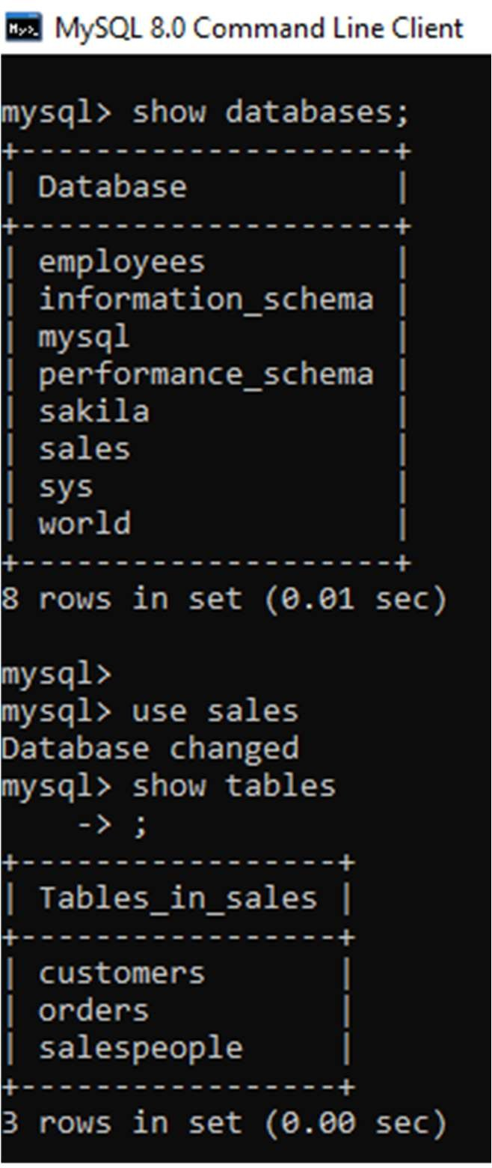

**Snum** is Primary key

**Sname** is Unique constraint

*Create table salespeople (Snum int NOT NULL, Sname varchar(15) NOT NULL, City varchar(15),Comm int, UNIQUE (Sname), PRIMARY KEY (Snum));*

|  |  |  |  |
| --- | --- | --- | --- |
| **Snum** | **Sname** | **City** | **Comm** |
| **1001** | Peel | London | 12 |
| 1002 | Serres | Sanjose | 13 |
| 1004 | Motika | London | 11 |
| 1007 | Rifkin | Barcelona | 15 |
| 1003 | Axelrod | Newyork | 10 |

*Insert into salespeople Values(1001,Peel,London,.12);*

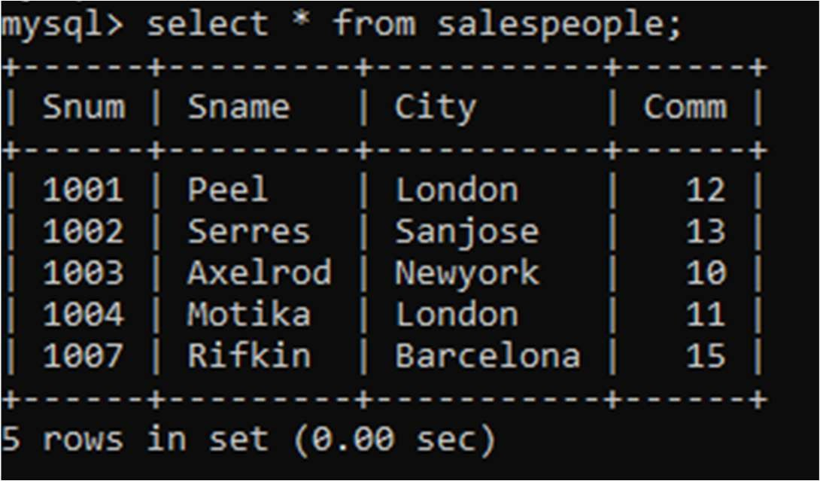

**Cnum** is Primary Key

**City** has not null constraint .

**Snum** is foreign key constraint refers Snum column of SalesPeople table.

CREATE TABLE Customers(Cnum int, Cname varchar(15), City varchar(15) NOT NULL,Snum int, PRIMARY KEY (Cnum),FOREIGN KEY (Snum) REFERENCES Salespeople(Snum));

|  |  |  |  |
| --- | --- | --- | --- |
| **Cnum** | **Cname** | **City** | **Snum** |
| 2001 | Hoffman | London | 1001 |

|  |  |  |  |
| --- | --- | --- | --- |
| 2002 | Giovanni | Rome | 1003 |
| 2003 | Liu | Sanjose | 1002 |
| 2004 | Grass | Berlin | 1002 |
| 2006 | Clemens | London | 1001 |
| 2008 | Cisneros | Sanjose | 1007 |
| 2007 | Pereira | Rome | 1004 |

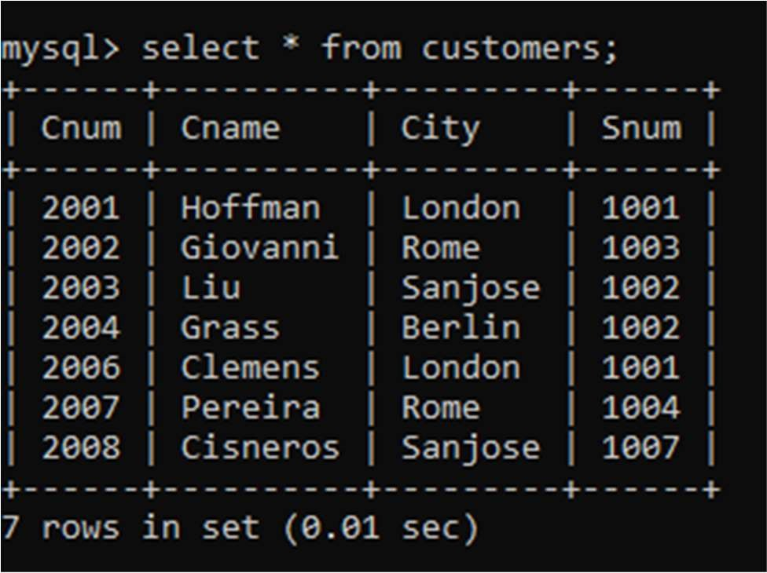

**Onum** is Primary key

**Cnum** is foreign key refers to Cnum column of Customers table. **Snum** is foreign key refers Snum column of SalesPeople table.

CREATE TABLE orders(Onum int,Amt float,Odate date, Cnum int, Snum int, PRIMARY KEY (Onum),FOREIGN KEY (Cnum) REFERENCES customers(Cnum), FOREIGN KEY (Snum) REFERENCES

salespeople(Snum) );

|  |  |  |  |  |
| --- | --- | --- | --- | --- |
| **Onum** | **Amt** | **Odate** | **Cnum** | **Snum** |
| 3001 | 18.69 | 3-10-1990 | 2008 | 1007 |
| 3003 | 767.19 | 3-10-1990 | 2001 | 1001 |
| 3002 | 1900.10 | 3-10-1990 | 2007 | 1004 |

|  |  |  |  |  |
| --- | --- | --- | --- | --- |
| 3005 | 5160.45 | 3-10-1990 | 2003 | 1002 |
| 3006 | 1098.16 | 3-10-1990 | 2008 | 1007 |
| 3009 | 1713.23 | 4-10-1990 | 2002 | 1003 |
| 3007 | 75.75 | 4-10-1990 | 2004 | 1002 |
| 3008 | 4273.00 | 5-10-1990 | 2006 | 1001 |
| 3010 | 1309.95 | 6-10-1990 | 2004 | 1002 |
| 3011 | 9891.88 | 6-10-1990 | 2006 | 1001 |

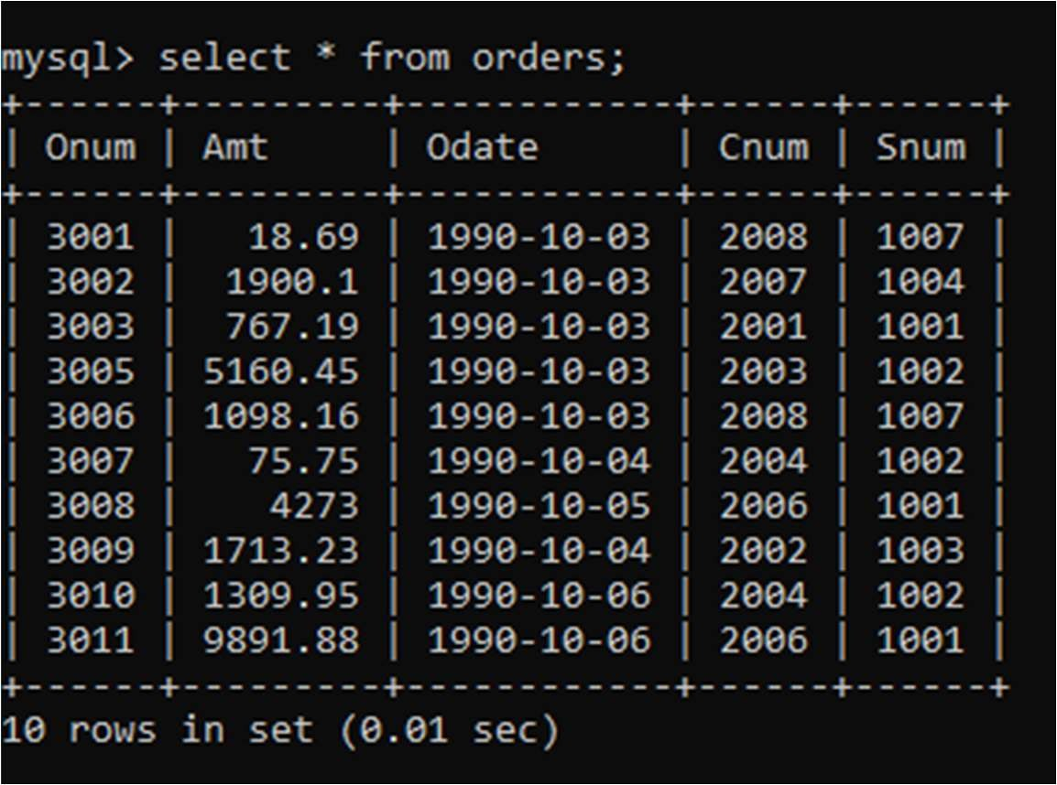

On the basis of above tables perform given below questions

1. Count the number of Salesperson whose name begin with **‘a’**/**’A’**.

*SELECT count(sname) FROM salespeople where sname like 'A%';*

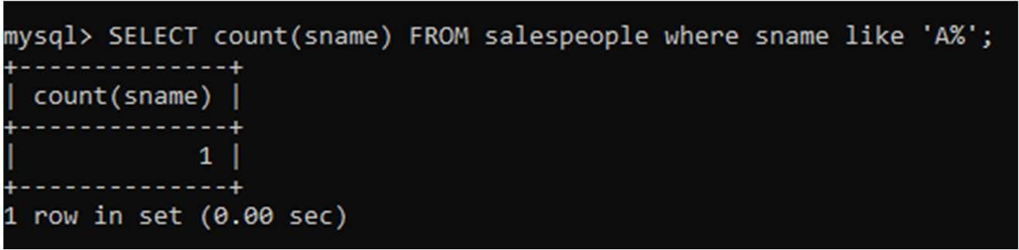

1. Display all the Salesperson whose all orders worth is more than Rs. 2000.

select orders.snum,sname,sum(amt) from orders right join salespeople on orders.snum=salespeople.snum group by snum having sum(amt)>2000;

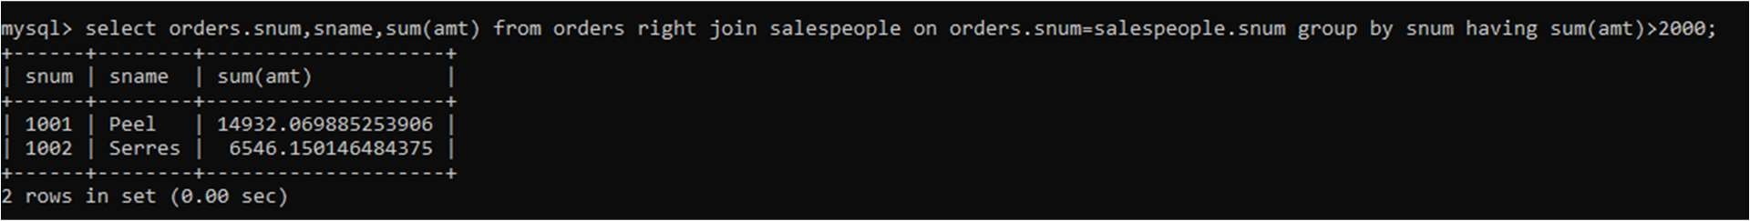

1. Count the number of Salesperson belonging to **Newyork**.

*SELECT COUNT(Sname) FROM salespeople where City='Newyork';*

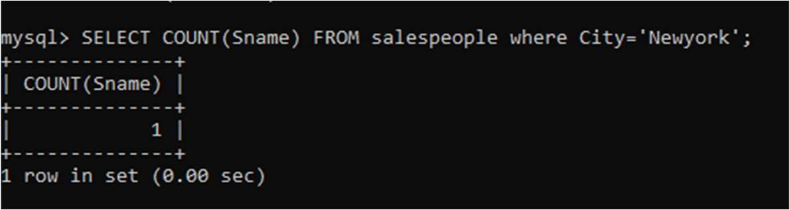

1. Display the number of Salespeople belonging to **London** and belonging to **Paris**.

*SELECT snum FROM salespeople where City='London' or City='Paris';*

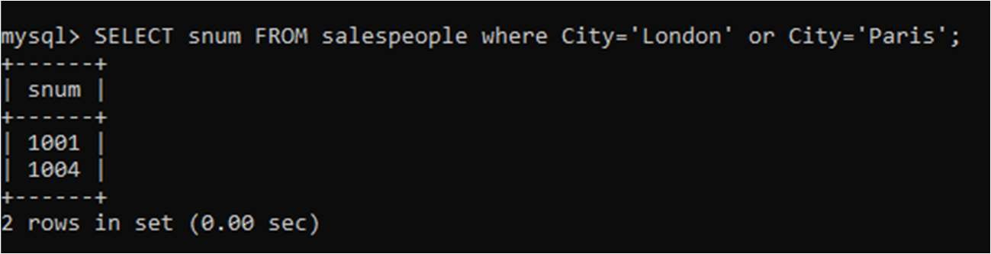

1. Display the number of orders taken by each Salesperson and their date of orders.

To display num of orders by each salesperson-

select sname,count(onum) from salespeople right join orders on orders.snum=salespeople.snum group by sname;

To display salesperson and their date of orders-

select sname,odate from salespeople right join orders on orders.snum=salespeople.snum order by sname;

